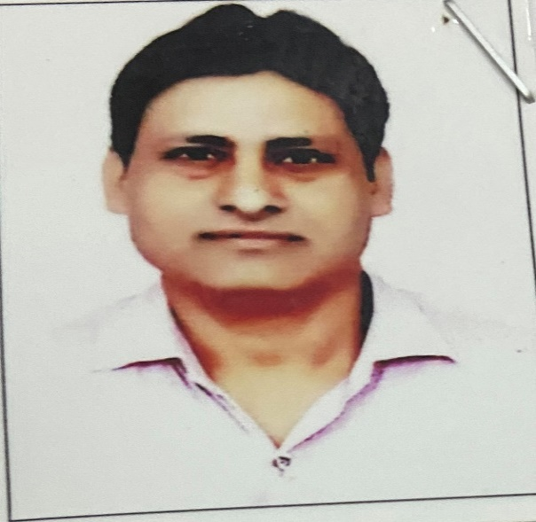

**Ajay Chauhan**

**Assistant professor in Nimbus School of Education**

**Area**

Primary Area: Education

Secondary Area: Science

**Contact**

Email: kchauhan.k80@gmail.com

Phone: +91-9759370398, 8273202121

**Education**

* M.Ed. from Jivaji University, Gwalior (M.P.)
* B.Ed. from C.C.S. University, Meerut.
* Post Graduate Diploma in Personal Management & Labour Welfare from Kurukshetra University.

**Teaching**

* Education
* Life Science
* Biology
* Zoology

**Academic Experience**

Faculty Member, William Jefferson Cliton Science Technology, Rampur, Maniharan, July 2005 onwards

Faculty Member, Shivalik College of Education, May 2008, onwards

Faculty Member, Krishna Institute of Education and Management, Saharanpur, June 2012, onwards

Faculty Member, Nimbus School of Education, _____________ onwards

**Professional Experience**

Nimbus School of Education

Nimbus Academy of Management